**POWER QUERY WRAP UP**

**TEXT FUNCTIONS IN POWER BI (POWER QUERY)**

1. **Merge columns**

I extracted the data from excel file in Power Bi and chose to transform it before loading. Since there were three different columns: Prefix, First Name, and Last Name, I merged them all into one as Full name. I also removed the first row because it was the headers of the previous data i.e., it said Prefix FirstName LastName.

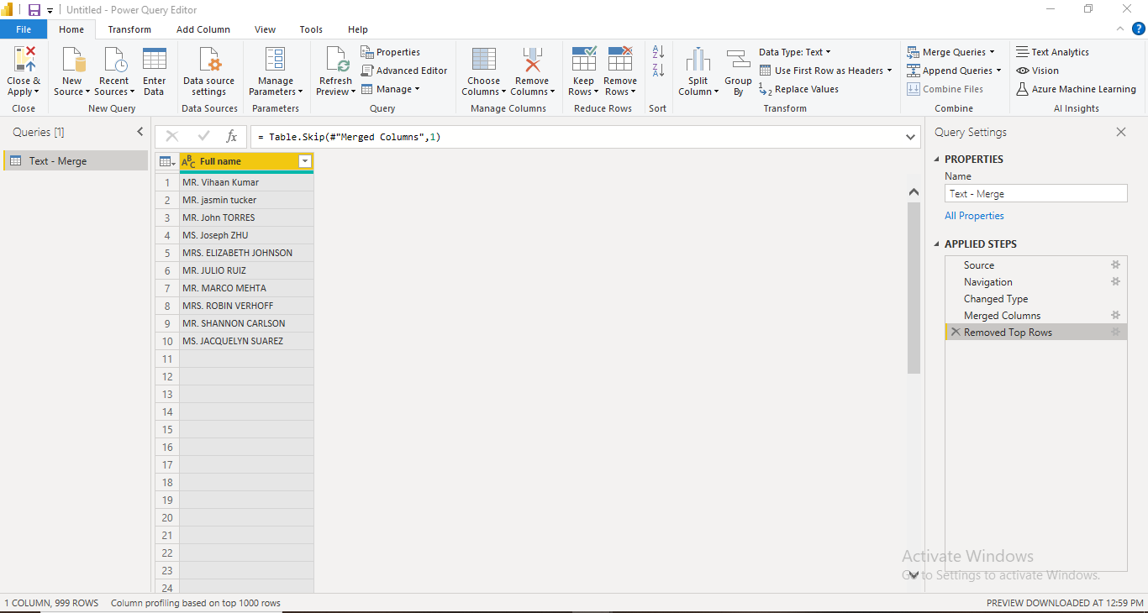

1. **Split & Trim Text in Power BI**

In our data, column A – Shipping address has messy data. For instance city, state, and place are all merged together but I want to split them all. Also, some rows even have emoty spaces or white spaces, so we need to transform our data.

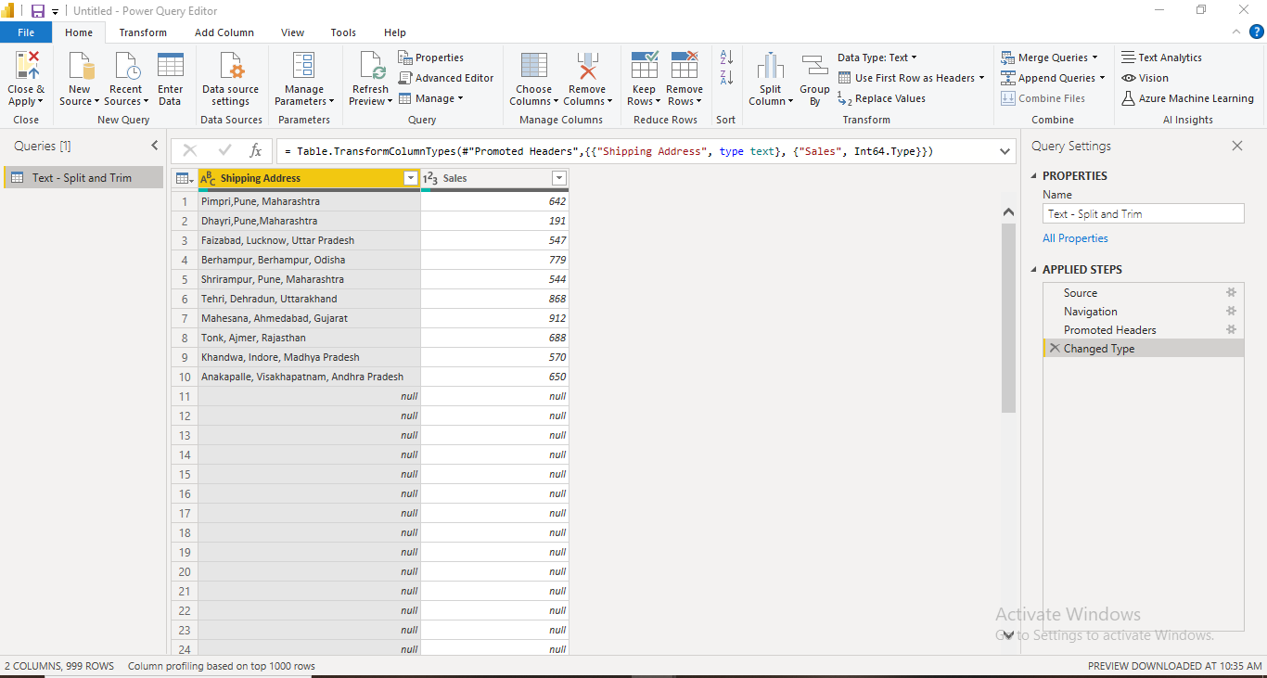

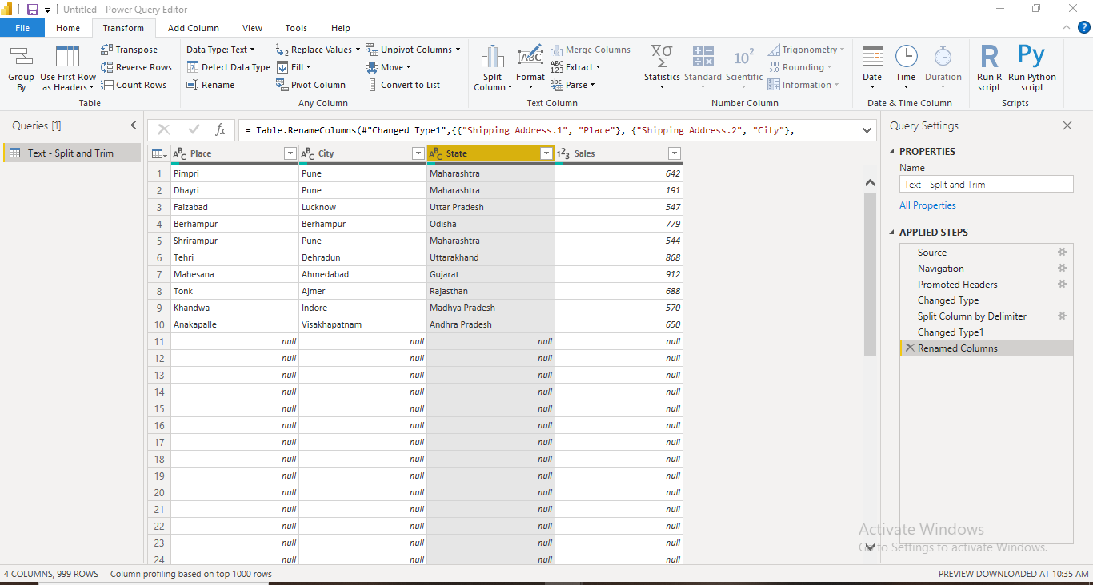

Below are some of the analysis we can make using our data:

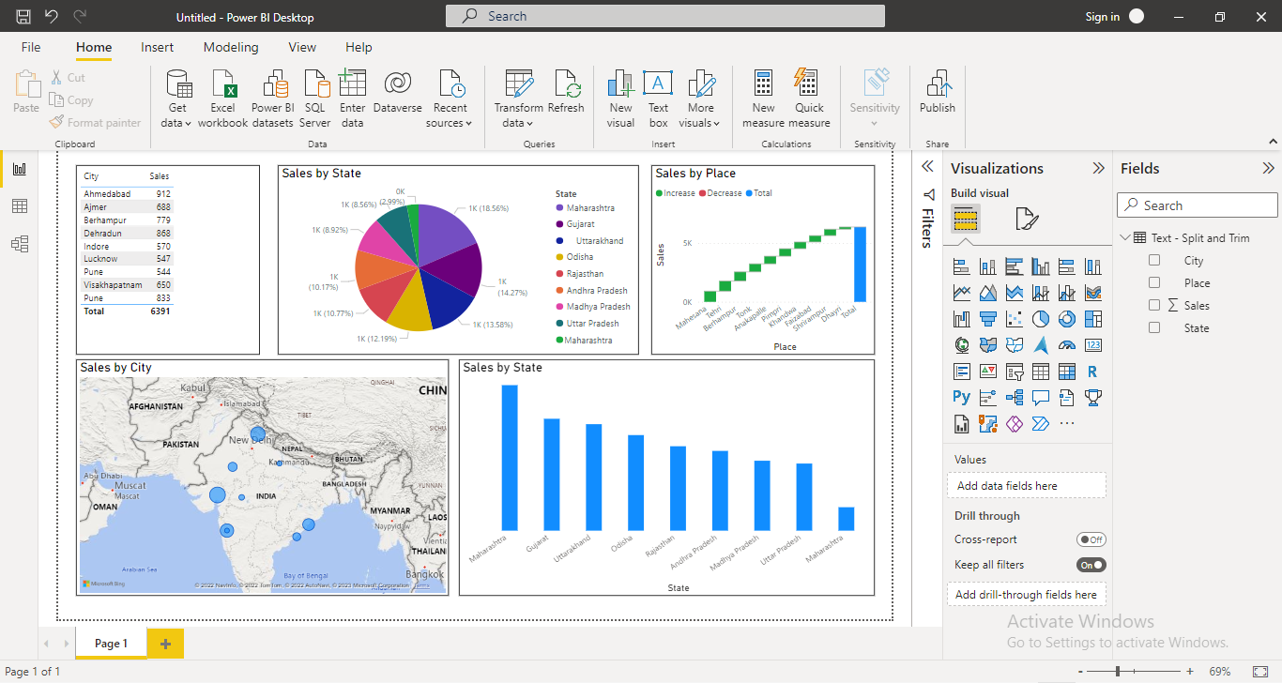

1. **Left, Right, & Mid Function**

Here, in this exercise, we will explore how to extract right, left or middle characters. Below is our raw data:

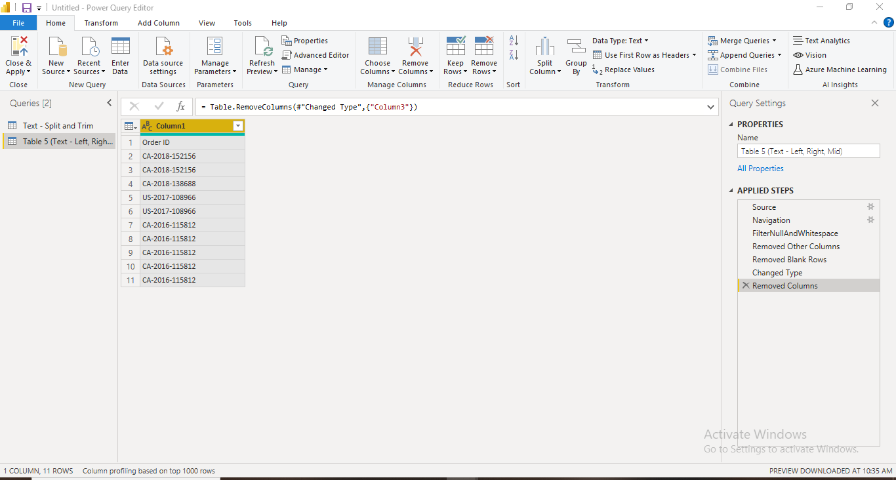

That was simple, but how do I extract the text when the dataset have delimiters like shown below?

1. **Upper, lower & Proper Case**

I got a distorted data as shown below:

I can change the case of my text in column 2 and 3 but first I made the first rows as headers. Next, from transform tab, I played with different text cases.

**DATE FUNCTIONS IN POWER BI (POWER QUERY)**

We can find out Year, Quarter, Month & Day from our date column:

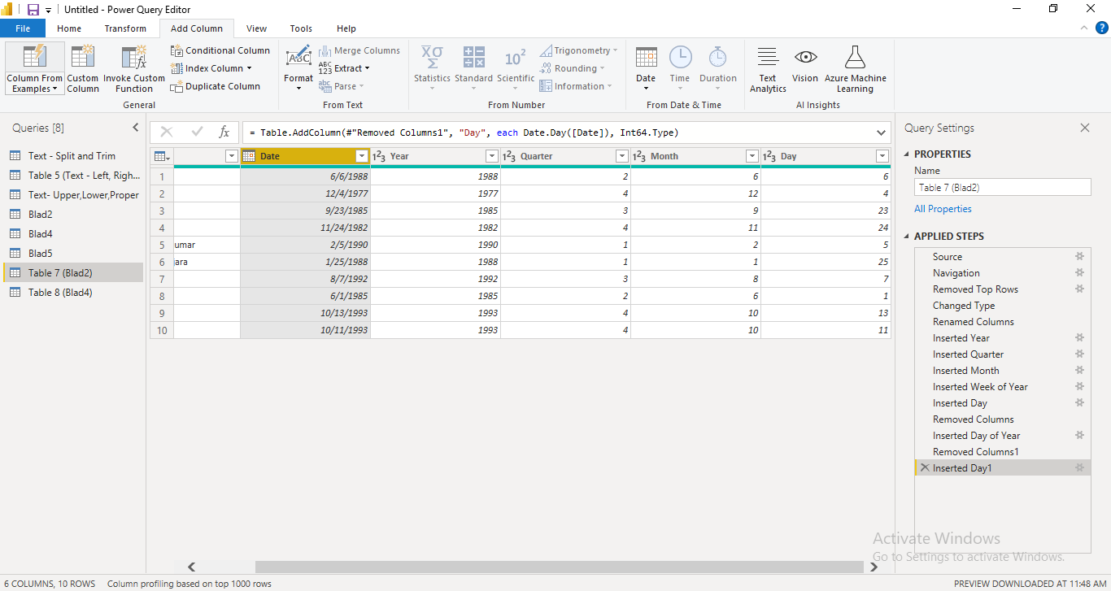

We can also find out the Month and Day Name just by a few clicks:

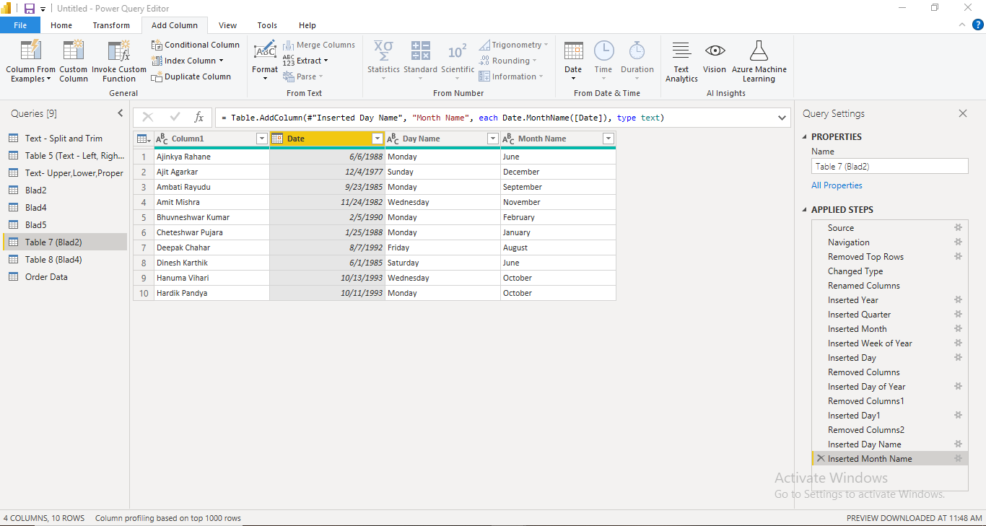

If we have two date columns, we can subtract them, find the earliest and latest dates in each rows, too:

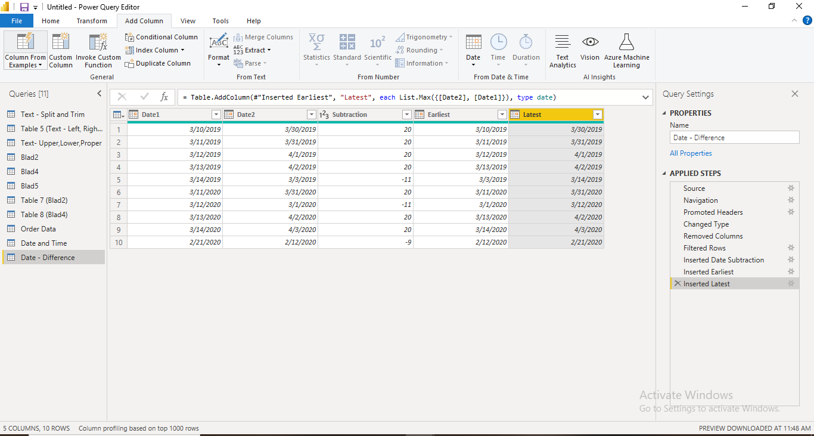

Suppose we have a column with both dates and time as shown below, but we want them in separate columns. We can also extract Date and Time in Power BI (Power Query).

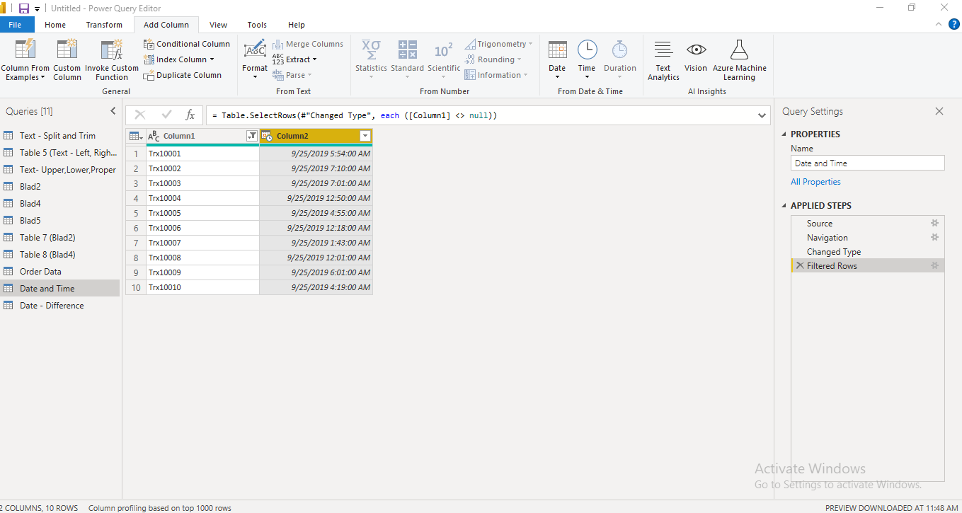

Lastly, from date of birth, we can calculate age of a person:

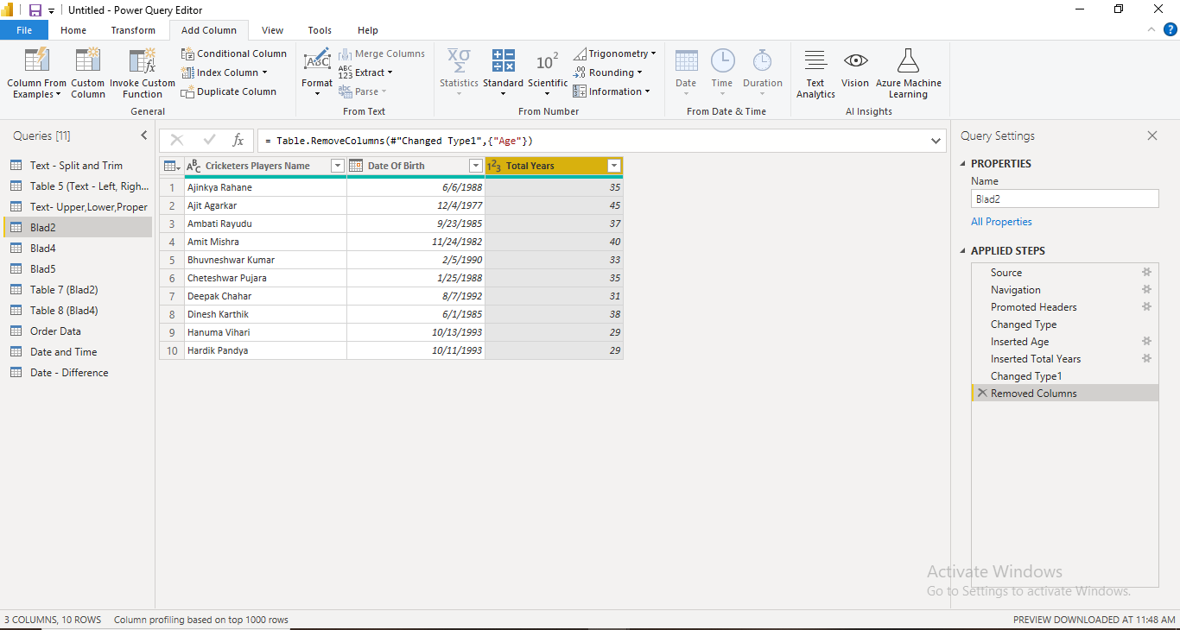

**NUMBER FUNCTIONS IN POWER BI (POWER QUERY)**

Here is the raw data:

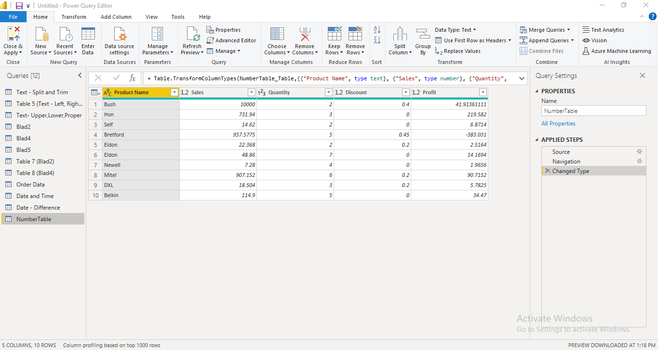

I want to calculate total sales, so I can utilize multiplication operation under numbers function. I chosed sales, quantity, and discount columns and multiplied them. But since some of the rows in discount table had data = 0, we got the final multiplication answer also zero. So we changed a formula a bit and here is the result:

If I want to calculate cost, I will subtract total sales and profit:

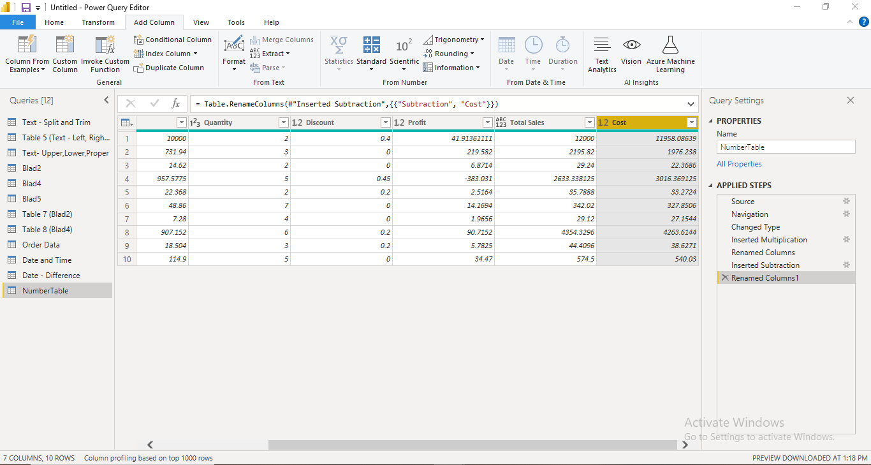

Now, we can also find Percentage. For example, we calculated 10 percent of total sales:

We can also roun our values, for example in the below picture, we rounded up, down and simply rounded values for the profits column:

Lastly, we can also determine whether our values are even or odd and what is the sign (positive or negative).

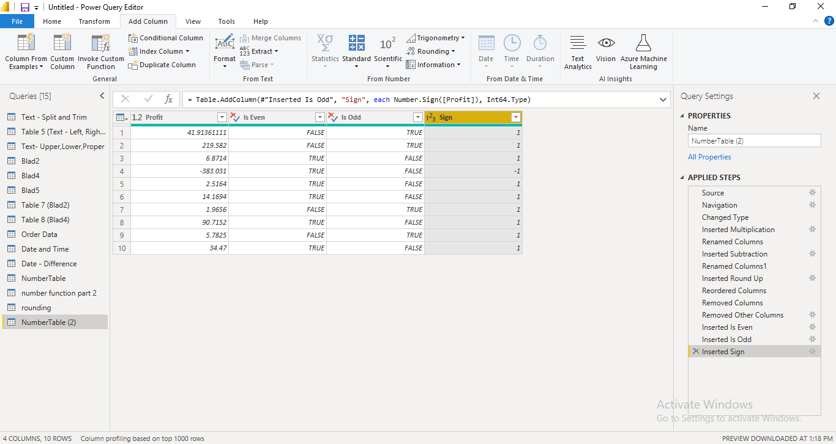

By selecting only positive +1, we will get the values that are profits. And upon selecting negative -1, we will get the loss values.

**Merge Files and Tables in Power BI**

We can merge data from different excel workbooks. For example, here we have two different excel files that we wish to merge in Power BI.



This is our Transaction table that we uploaded in Power Query:

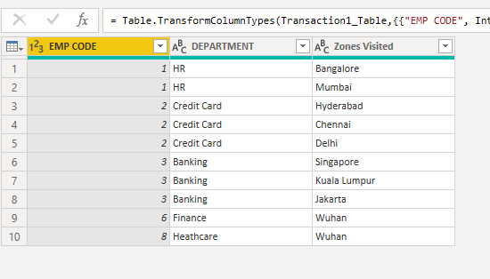

And this is Master table

We want to merge these two in a new query. So we build a relationship since both have EMP CODE column. Also, since we only needed SALARY column from Master Table in our Transaction Table, we selected that.

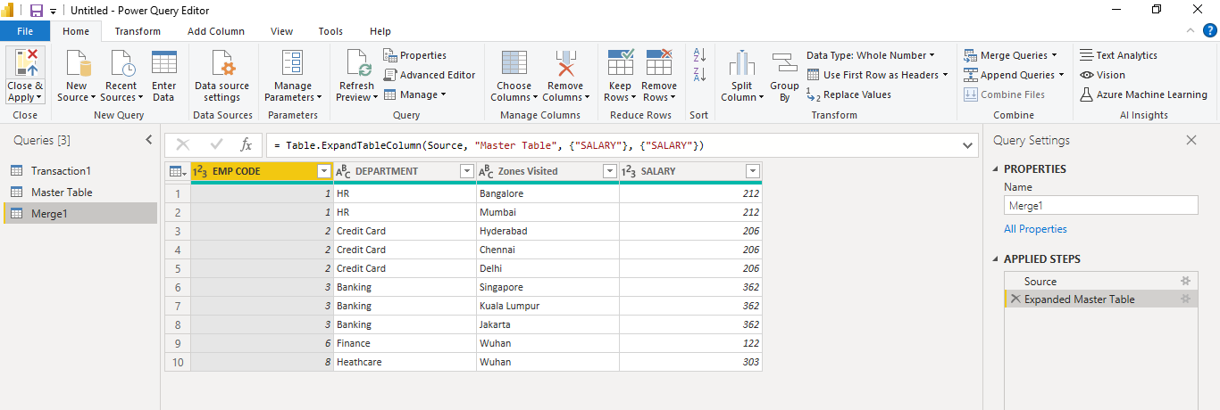

**Column from Examples**

Like flash fill feature in excel, we can use column from examples in power BI. Here are a few examples:

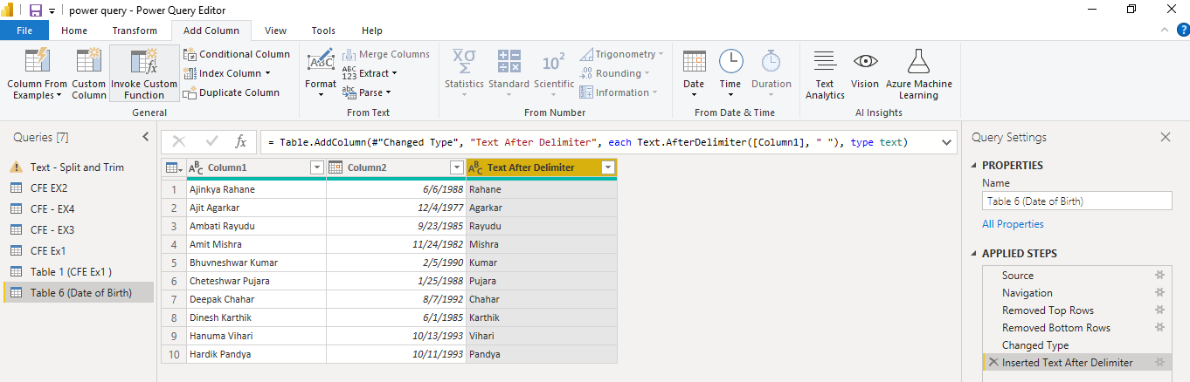

In another example, our dataset had 3 columns: category, sub-category, and product ID. So we used column from examples > from all columns so the final result is a merged column:

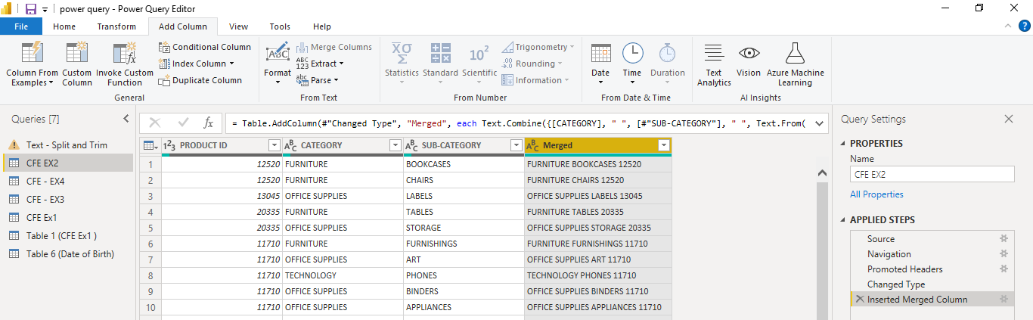

Again, using column from example features, we extracted day, month, year, and even a custom column from our date column:

In last example, we have both alphabets and numeric values in a single column, so again using column from examples, we extracted each values in a separate column. And that’s how our clean data looks now:

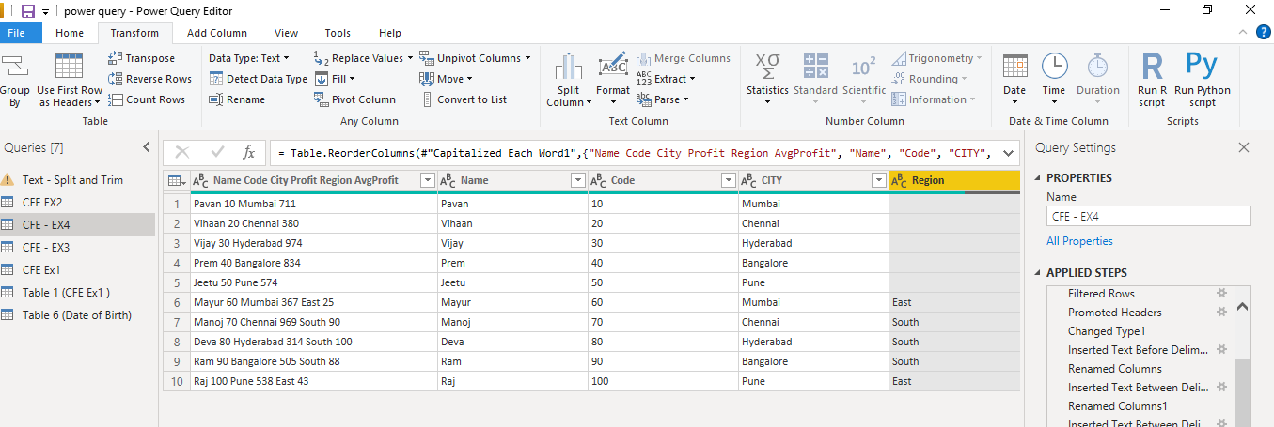

**Conditional Column in Power BI**

We have this dataset:

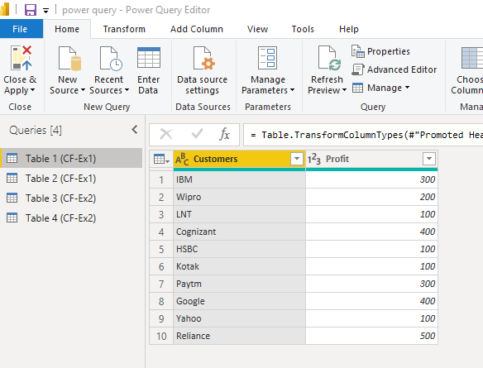

We want to apply condition in profit column. 3 conditions: <200 is low profit, >400 is high profit, and the range 200-400 represents average profit.

But what if we want to apply condition to two different columns like the below data?

Here, based on gender and marital status, we will give the anmes a prefix i.e., Mr.,Mrs., or Miss.

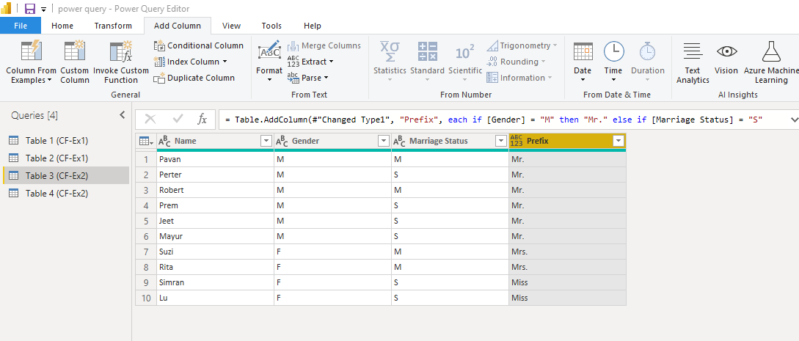

Now, comparing two columns:

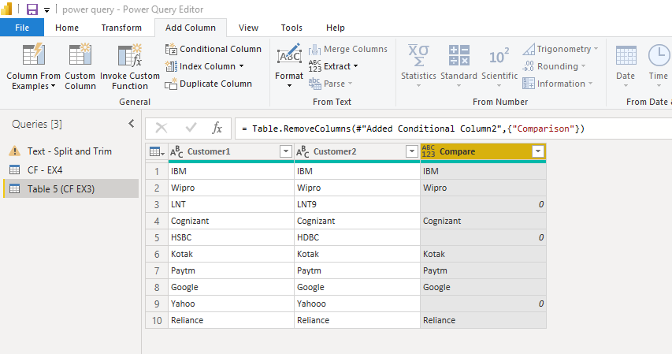

**Exploring other features in Power BI**

* We can fill down a value in Power Query:

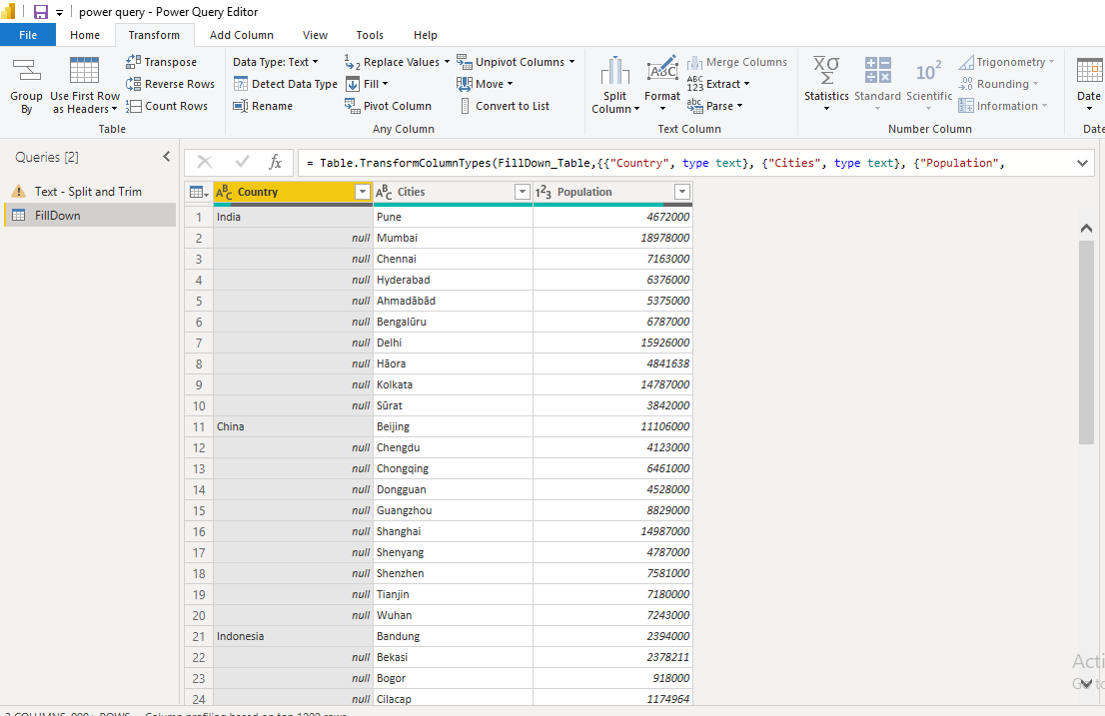

* **Grouping**

In the dataset below, I want them to group by country so I can see what is the average score and total population by country:

* **Transpose**

In below dataset, we have so many null values. We can see only3 rows have the values, so Ill just remove other rows first.

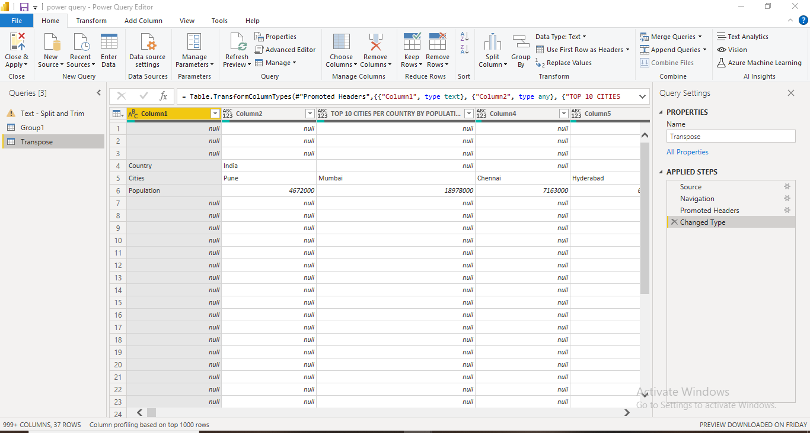

Next, I will transpose these rows:

